NEDSHAPE
Gym Wellness Membership Management Web Application
Technical Spec
Document Information

Title: NEDSHAPE : Gym Wellness Membership Management Web Application Platform
Subject: Technical Specification
Project: NEDSHAPE System Development
Author: Heather Sadie
Version Control:
Revision History Date of Revision Version Number
First Draft
Revision 1
2019/08/28

Version 1.0

Revision 2

Distribution History
Name
Role
Date
Revision 1

Mahesh
Sponsor

Aadil
Bus. Project Manager

Vishallen
Bus. Manager

Revision 2

Heather

Dev. Project Manager

Revision 3

.

Table of Contents
-
1. Introduction 8
2. Project Scope 8
2.1. Definitions, Acronyms and Abbreviations 8
3. SYSTEM OVERVIEW 8
3.1. Classes 9
3.2. Database Model 9
3.3. Design Considerations 9
3.4. Assumptions 10
3.5. Defined Terms 10
4. System Characteristics 11
4.1. URL Name 11
5. User characteristics. 11
6. Technical Specification 14
6.1. SPRINT 1 : (functions marked in yellow) 15
6.2. MEMBER SIGNUP 16
6.2.1. Display 18
6.3. Login to Internet App 20
6.3.1. Display 23
6.4. FORGOT Password 24
6.5. Reset Password 26
6.5.1. Reset Password 28
6.7. Membership User 30
6.7.1. Select Gym 30
6.7.1.1. Process Characteristics 30
6.7.1.2. Search Gyms 32
6.8. JOIN GYM 33
6.8.1. Join Gym 33
6.8.1.1. Process Characteristics 33
6.8.1.2 Join Gym 35
6.9 PAYMENT API 37
6.9.1 PAYMENT API 37
6.9.1.2 Process Characteristics 37
6.10 ARRANGE FIRST VISIT 39
6.10.1 Process Characteristics 39
6.10.2 Book First Visit 41
6.11 MEMBERSHIP DATA 42
6.11.1 Process Characteristics 42
6.11.2 MEMBER DETAILS 44
6.12 Member : Statements 44
6.12.1 Process Characteristics 44
6.12.2 Members Statement Page 45
6.13 Gym System Config 46
6.13.1 Process Characteristics 46
6.13.2 Gym Config Page 48
6.14 Audit Log 48
6.14.1 Process Characteristics 48
6.14.2 AuditLog Page 50
6.15 Collections 51
6.15.1 Process Characteristics 51
6.15.2 Collections 52
7. SPRINT 2 (functions marked in blue) 53
7.1. Gym and service Management 53
7.1.1. List of Gyms 53
7.1.1.1. Process Characteristics 53
7.1.1.2. Activated Gyms List 54
7.2. Platform Administration 55
7.2.1. Platform Configs 55
7.2.1.1. Process Characteristics 55
7.2.1.2. Display System Config fields and Add Broadcast message 57
7.2.2. List of Platform Users 58
7.2.2.1. Process Characteristics 58
7.2.2.2. List of Users 59
7.2.3. List of Services/Products Types 61
7.2.3.1. Process Characteristics 61
7.2.3.2. Products/Services Page 62
7.3. Platform Finance 63
7.3.1. List of Membership Statements 63
7.3.1.1. Process Characteristics 63
7.3.1.2. Member Statements Page 65
7.3.2. List of Gym Payments 67
7.3.2.1. Process Characteristics 67
7.3.2.2. Gym Payments Page 68
7.4. Batch Monitor Programs 69
7.4.1. Generate Member Statements 69
7.4.1.1. Process Characteristics 69
7.4.1.2. Statement Layout 70
7.4.2. Generate Gym Payments 71
7.4.2.1. Process Characteristics 71
7.4.2.2. Payment Layout 72

Introduction

This document is the Nedshape intended for use by the Nedshape Development Project team. It provides direction and template specifications to assist the relevant management or technical staff, whether it is for Etech or Direct Rewards. It is also useful background reading for anyone involved in developing or monitoring the Nedshape : Gym Wellness Membership management web application.

Project Scope
This development project is based on the Nedshape conceptual- diagram and discussions between Direct Rewards and Etech.
The Nedshape project includes the application development of a Gym membership management web application to enable Direct Rewards and it’s associated gyms to manage gym memberships and rewards. The application will allow for fitness and health related products and services to be offered to membership holders. The application consist of three parts, namely a back-office that will be managed by Direct Rewards, a membership component and a gym management component.
The development is based on Microsoft Window and programming in .Net MVC Framework, Language : C# with a SQL database. Standard API’s will be developed in JSON XML.

Definitions, Acronyms and Abbreviations

SYSTEM OVERVIEW

Classes

The following classes are identified followed by a Database Model:
- User Type (Member/Gym/Back-Office)
- Users
- Roles
- User Roles
- User Password
- System Config
- System Broadcast
- Audit Log
- Product Category
- Members
- Gyms
- Products
- Member Products
- Member Statements
- Client Statements
- Payments

Database Model

Design Considerations

- Development Language: .Net C#
- Programming Framework: MVC
- Services: WSDL (XML or JASON)
- Database: SQL

Assumptions
The following assumptions are made:
- All users will have access to the internet to use the system
- The system will be developed as an internet-based application and will be accessible by all stakeholders from any standard browser
- Most processes are automated
- All parts of the system are configurable and maintainable by staff of the Direct Rewards
- The system is developed in such a way that adding functionality will be easy and uncomplicated

Defined Terms
The following Terms and meanings for this document:
Term/Word/Clause | Meaning
MEMBERS | Also referred to as memberships from time to time. Members are member of the Nedshape Wellness Program that signup for membership at Nedshape associated gyms.
GYM | Gymnasiums that offer fitness services and infrastructure to be used by members
PRODUCTS | Products and services offered by gyms to the members
BACK OFFICE USERS | Users are employees of Direct Rewards, that will manage the back office such as System Administrators, Financial personnel, managers, operators.

System Characteristics

URL Name
The domain Nedshape.co.za has been secured for this platform by Etech Information Solutions . The test site will be hosted on the TestNedshape.co.za:

User characteristics.
The users will either be Frontend users (Gyms and Members) or Backoffice users (Direct Rewards), and each of these users will have access to different forms for depending on their roles and permissions.

  - Users
There are 5 types of users:
- Members (majority of users)
- Gym Users
- System Administrators
- System Operator
- Financial User

    - MEMBERS
These users can select Gyms, sign up for membership at selected gym(s) and purchase for products/services, Pay for membership and products/services, view payment statistics, add contract documentation and update membership information
The member will receive a system generated correspondence via email for all notifications.
    - GYM USERS
These users will be part of the frontend users and will have access to its gym members and functions that will enable the management of products/services and the ability to track membership payments.
    - SYSTEM ADMINISTRATORS
The system administrator users are back-office users that will have access to configure the rules of the system, manager Backoffice users, activate gyms.
Password reset function must be automated.
All exceptions experienced on the system must automatically be sent to the System Administrators for action.
    - SYSTEM OPERATORS
The system operator will be responsible for the management of gym information, product/service information, reward information and any related forms associated with gyms and/or product.
The system operators will also have access to all exceptions on the system for further actions.
    - FINANCIAL USERS
The Financial user must have access to all financial related information and will be expected to manage payment runs when payments to gyms are being distributed. The financial user is also responsible for the financial health of the business and the information required to manage the financial health.

  - User/Function Matrix
Role | Functions
System Admin | All functions
Gym Admin | All Gym Functions
Member | Select Gym, Join Gym, Pay membership, arrange first visit, Member Dashboard, Member Statements, Member data
Gym User | Gym Membership, link services, Member Statements and Dashboard
Financial User | Payment Management, Member Statements, Distribution of Funds
Operations User | Awaiting Activation, Active Gyms

Technical Specification
The following diagram illustrates the conceptual view of the system:
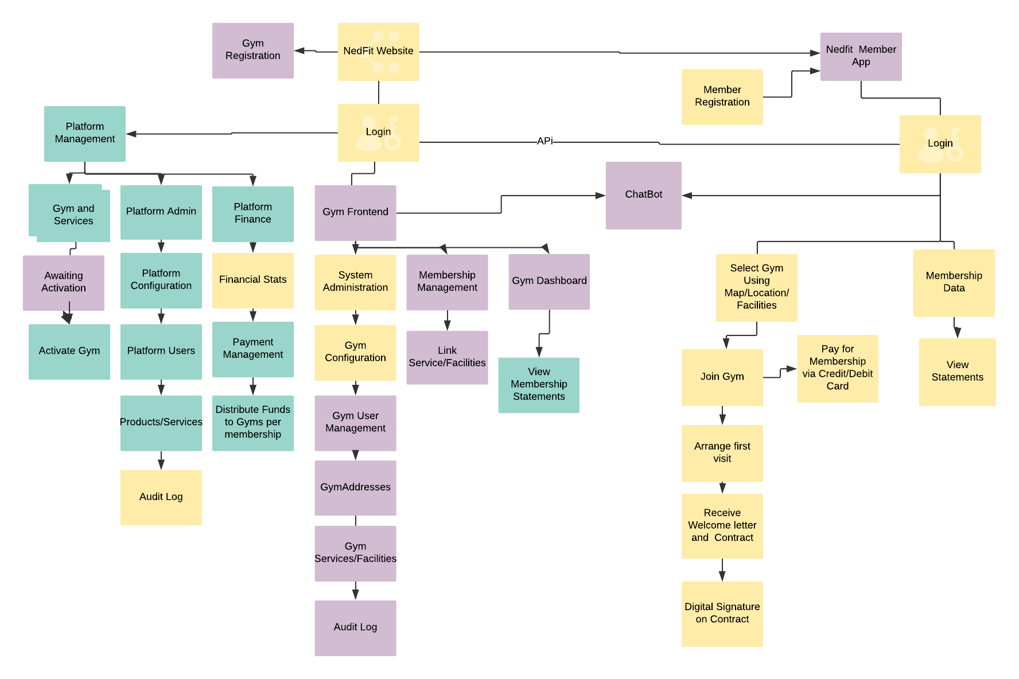

SPRINT 1 : (functions marked in yellow)

The website should have two buttons for the Nedshape App. LOGIN and SIGNUP.
The SIGNUP button will take the user to a page to signup to use the system as a member or a gym.
The LOGIN button will take the user to a login page, to login to the system.
See example:
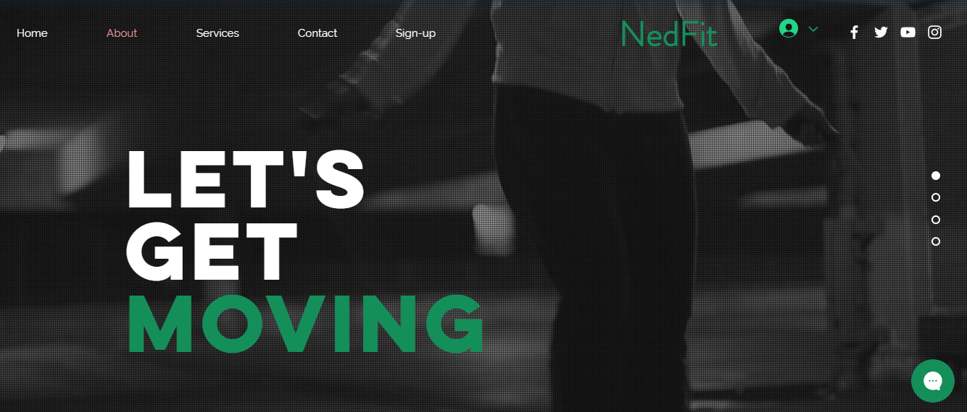

MEMBER SIGNUP

Process Characteristics Table
Process Name: | Member Signup
Process | UC0001
Process Background: | The user will sign-up to become a member. Once the member has signed up and paid the member will receive login details and the gym admin users will receive correspondence regarding the member that signed up.
Process Objectives: | To allow the user to sign up as a member | Process High Level Key Activities: | Once the user selects to sign up the user clicks as a member or as a gym  Membership details will be captured after the user selects the gym to sign up to  The member will also pay for the gym membership using their Nedbank card.
Precondition | The URL must exist |  | www.testNedshape.co.za  www.Nedshape.com
Constraints: |  | Target Clients: | Prospective Nedbank account holders
Trigger From: | Browser | Trigger To: | Signup page
Rules: | - Allow user to select the SIGNUP button on the Nedshape website  - Prompt the user to respond to select As a gym owner or as a Nedbank Account Holder  - If the user selects as a gym activate the Gym Sign up page (this is part of sprint 2, so comment this portion out for now  - Allow user to select a member signup and display the member sign up page  - Allow user to enter details according to display  - The following fields are required:  - Name  - Surname  - Date of Birth  - Cell Number  - Email Address  - Province  - Town  - Address  - Use Google maps to find address coordinates and save to user record.  - Validate the ID number - http://geekswithblogs.net/willemf/archive/2005/10/30/58561.aspx  - AgreeIndicatorAllow user to read the Terms and Conditions by linking to a document  - Add the member record with a status – to be verified  - Only allow the user submit the member application once the agree indicator has been set, otherwise protect the submit button  - When storing the user in the user table link the role Member to the user and save as a member type  - Submit the activation email to the user  - Allow the user to upload a selfie, the signed membership contract and copy of passport  - When the payment is made user the Iveri Payment solution and store the payment date and amount in the UserPayments table with a unique reference received from Iveri.
Actor: | Prospective member

Step No: | Step Name | Step Description | Input | Output | Step Type | Data Elements | Message | Rules
TRIGGER 1
1. | Activate URL | From the Browser the user will activate the Nedshape signup page, verify whether the user is a account holder or a gym owner | The browser | See Display | System | URL | None | 1,2,3
2 | Validate captured Fields | Validate fields:  - Birthdate – must be valid and must be 18 years or older  - Id Number must be valid | Page | User | User/System | Member Table |  | 4 - 10
3 | Link to Terms and Conditions | Allow user to link Terms and Conditions Document | Terms and Conditions |  | System |  | Yes | 8
4. | Upload documents | Allow the user to upload documents and link them to the user record | Upload doc | UserDocs | System/Users |  | Yes | 13
5 | Add member Records (User) | Only Add member user record when the submit button has been clicked, Then display message “Thank you for signing up to be a member on Nedshape, please activate your login from the email that was sent to you” | Page | Users | System/Users |  | Yes | 12
7 | Member Role | When adding the agent make sure to link the Agent Role to the user | User  Role | UserROle | System |  |  | 11

Display
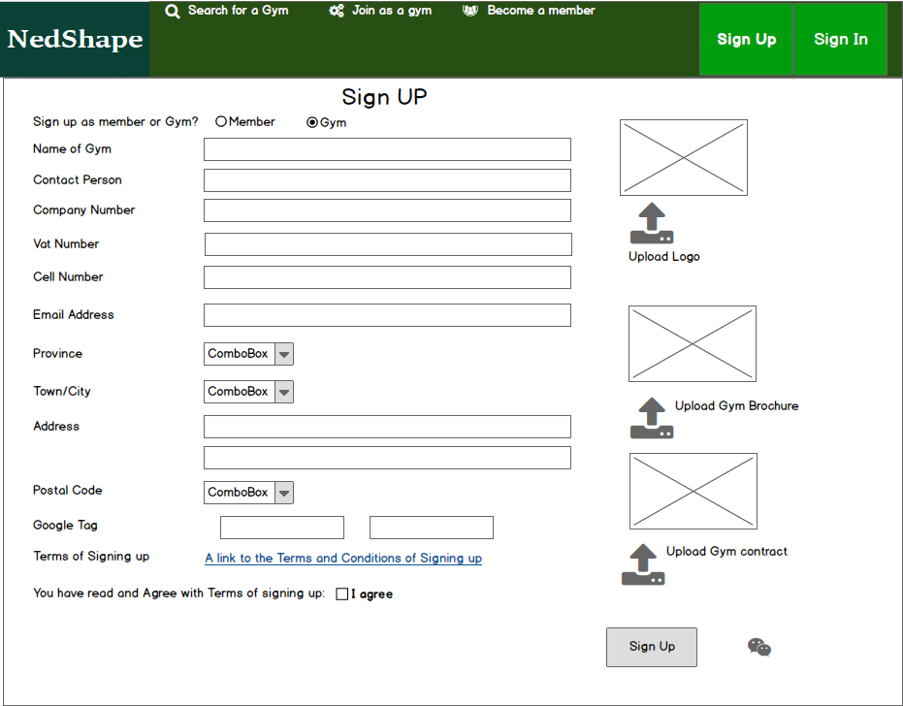

Login to Internet App

Process Characteristics Table
Process Name: | Login to
Process | UC0002
Process Background: | The user will login to the Nedshape system with his/her email address or cell phone number, and password.  If using password authentication, the resetting of passwords should be automated, in other words should the user have forgotten his/her password there should be a button, an email should be sent to their email address or whatsapp message allowing them to reset their password. When a user’s email address is not valid, then inform the user that the email address is not available.  Once logged in load the user type, role and permission for the use of the session and building of menu’s and sub-menu’s. where applicable also load the clients and/or products that the user is linked to.
Process Objectives: | To Activate the URL  To see if the user may access the Nedshape System  To Present a Login Function  To interface the Nedshape Website  To obtain Role and Permissions  TO build the menu and submenus for the role | Process High Level Key Activities: | - Once entering the URL display the landing page with the Login  - When clicking on the Login button present the Login Popup  - Check if the user is registered on the Nedshape system and that the user is still active  - Validate the password  - Get permissions  - Build Menus and submenus
Precondition | The URL must exist |  | www.testnedshape.co.za
Constraints: | The user must be registered. | Target Clients: | Agents and BO users
Trigger From: | Browser | Trigger To: | For Agents to Agent Landing Page  For BO to BO Landing Page  For Trading Partners – TP Landing Page
Rules: | - URL must exist  - The user must exist on the Nedshape Users table and must be active  - IF the user does not exist display Message “Your Account does not exist – please sign up as an member if you are a Nedbank Card holder or contact the support desk ”  - If the user exists, check the user’s password – it should match the password on the database  - If it does not match then then display message “ Your Account or password is incorrect”  - If the reset indicator is on, force the user to reset the password  - Allow the user to click on the Forgot Password button  - Once authentication is successful, Build the appropriate menus and submenus and pass control the Landing Page  - Display the Dashboard according to the UserType – Admin sees all, Finance only the financial related functions and Reporting menus and submenus,  - If a user has tried logging in more than 3 times the forgot password pop should appear.  - A new password must be confirmed by making the user type it in twice
Actor: | Back Office User : Ops, Finance, System Admin, Gym Users, Members

Step No: | Step Name | Step Description | Input | Output | Step Type | Data Elements | Message | Rules
TRIGGER 1
1. | Activate URL | From the Browser the user will activate the Nedshape system URL and click on the Sign-in button | The browser | See Screen Design below | System | URL | None
2 | URL exists | If yes, go to 4  If no, go to 3
3 | URL does Not Exist | Browser will display that the Page does not exist |  |  | System |  | Yes
4 | Does User exist? | Check if the user exists on the User table and it is active | User Code (either Email or Cell Number) | Users | System |  | NO | 2
5 | IF User does not exist display message,  Else go to 6 | If the user does not exist display – You do not have access the Cash4Leads system – please sign up as an agent. | User Code (either Email or Cell Number) |  |  |  | Yes | 3
6 | If the reset indicator is on  Else go to 7 | If the reset indicator is go to 6..4 Reset Password. | Users
7 | IF the password is incorrect  Else go to 9 | Display ‘user account code or password is incorrect.’ And allow user to try logging I again. | Users |  | User |  |  | 6
8 | How many failed login attempts | If the user has tried logging in more than 3 times then block the account and take the user to the forgot password process | User |  | System | Account Code  Password  Number of attempts |  | 6
8 | Build the menus and submenus | Check the role and permission and build the appropriate menus and submenus | Users  Roles  UserRoles |  | System | Id Number  Password  Cell | Yes | 7,8,9
9. | Landing Page | Pass the necessary control to initiate the Dashboard for the specific type of User | User
10 | Allow user to click on Forgot Password | Pass the user to the forgot password process with the user account | Users | Users | User/System | Users  Audit Log | Password  Reset indicator | 6

Display

-

FORGOT Password

Process Characteristics Table
Process Name: | Forgot Password
Process : | UC0003
Process Background: | When the user clicks on the forgot password button the forgot Password pop up must appear. The system will send the user
Process Objectives: | Reset user password | Process High Level Key Activities: | - Allow user to select reset password  - Send the user a new temporary password to email  - Set the reset indicator to on
Precondition | The Login Account must exist
Constraints: | The user must either have access to the email and/or the cell number registered on the users table | Target Actor: | All users of the system
Trigger From: | - Login Function | Trigger To:
Rules: | - Set the reset indicator to on in the User record  - Generate a password  - Update the password on the user record  - Email user with the new password with a link  - Use emails  - Upadate the Audit Log
Actor: | All Users

Step No: | Step Name | Step Description | Input | Output |  | Step Type | Data Elements | Message | Rules
TRIGGER 1
1. | The user clicks on forgot password | The system must set the reset indicator to on and generate a temporary password. The temporary password should also be updated on the database | Forgot Password |  | Users | User/System | Users  Reset Indicator  Password  Audit Log | None | 1,2,3
2. | Send User temporary password | Send the user an email with the new temporary password and link to signon | Users |  |  | System | Users | None | 4,5
3. | Update Audit Log | Update audit log for Users | Users |  | Audit Log | System |  |  | 6

See previous display

Reset Password

Process Characteristics Table
Process Name: | Reset Password
Process : | UC0004
Process Background: | The reset password process will either be initiated by the user by clicking on the reset password button or through the forgot password process. Once the password is reset, pass control back to the Login process.
Process Objectives: | Reset user password | Process High Level Key Activities: | - Display pop-up Reset Password page  - Protect the User Account code  - Force user to enter the new password and the confirm password
Precondition | The Login Account must exist
Constraints: |  | Target Actor: | All users of the system
Trigger From: | - Login Function or if the user’s reset password is set to on | Trigger To:
Rules: | - Display the Reset Password Page  - Protect the User Account code  - The new password and the confirm password must be the same before the system can update the password on the user record  - Update the password on the user record  - Set Reset Indicator to off  - Update the Audit Log  - Pass control to back to Login
Actor: | All Users

Step No: | Step Name | Step Description | Input | Output |  | Step Type | Data Elements | Message | Rules
TRIGGER 1
1. | New Password | Force the user to enter the new password and the confirm Password. | Users |  | Users | User/System | Users | None | 1,2,
2. | If the new password is equal to the confirm password go to 3 else 2 | Display message The new password is not the same as the confirm password’ and clear the confirm password for recapturing, but allow the user to enter both the new password and the confirm password if they so wish | Users |  | Users | User/System | Users | None | 3
3. | If the passwords are the same, update the User Record | Update the user password and set the reset password indicator to off. | Users |  | Users | System |  |  | 4,5
4 | Update the User Record and the Audit Log | Update the audit log | Users |  | AuditLog | 5 | Audit Log
5 | Pass control to Landing Page | See 6.

Reset Password
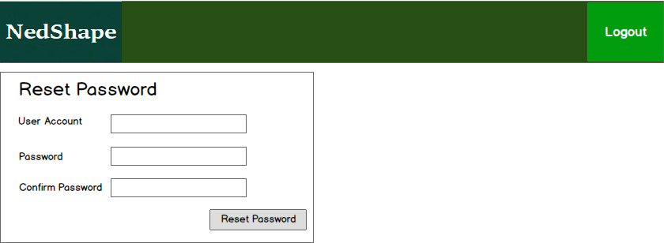

Landing page /Home Page Design
- See role/function to determine the menu/submenu to land on.

dashboard for backoffice users

Process Characteristics
Process Characteristics Table
Process Name: | Landing and Menus
Process Number: | UC 00005
Process Background: | This process is the system page/Dashboard/Landing page and Building of Menus and submenus for Backoffice users according to their roles, of the Back Office (BO) users once successfully signed in using the Login process.
Process Objectives: |  | Process High Level Key Activities: | - Build specific menus and submenus dependent on each different type of backoffice user and its tasks
Precondition | All users | Screen Layout | 6.6.2
Constraints: | Browsers | Target Clients: | All users of the system
Trigger, From: | URL | Trigger To: | Depending on type of user:  - Financial Users  - Other BackOffice users
Rules: | - Display the Landing page depending on Type of user  - For BO Users Operation – the landing page should be Gyms Waiting Activation  - For BO Users Admin – the landing page should be Platform Admin  - For BO Users Finance – the landing page should be Financial Stats  - For Gym Users – the landing page should be Gym Management  - For Members – the landing page should be Member Dashboard  - Build Menus and submenus for the role that the user is in
Actor: | All users of the system

Step No: | Step Name | Step Description | Input | Output |  | Step Type | Data Elements | Message | Rules
TRIGGER 1
1. | Build Landing Page | Build the landing page (see designs below) according to user type and UserRole. | Users |  | Dashboard | User/System | Users | None | 1-6
2. | Build Menus and submenus | Build menus and submenus in accordance with UserRoles | Users  UserRoles |  | Menus and Submenus | User/System | Pages | None | 7

Membership User

Select Gym

Process Characteristics
Process Characteristics Table
Process Name: | Select Gym
Process Number: | UC 00006
Process Background: | This process allows member users to select a Gym to join, by using their own address as MY HOME, or a entered location or a specific Gym Type/Service
Process Objectives: | Select a gym using gps coordinates for a selected location or a specific type of gym or gym offering a specific service | Process High Level Key Activities: | - Allow user to search for gyms near their home, a specific location or a type of gym  - Allow the user to click on the gyms for more information  - Allow the user to select a gym to join  - Link the member to the gym
Precondition | User must be a member | Screen Layout | 6.7.1.2
Constraints: |  | Target Clients: | Prospective Member
Trigger From: | Menu Selection – Gym Home | Trigger To: | From Login of member
Rules: | - Although the page designs are done for a mobile phone, ensure that the page is effectively designed for a laptop/pc  - Add the members address as my home  - Allow the user to search by gym name or partial name  - Allow the user to select another location, display all the gyms near the location and display on a map with approximate kms from location  - Allow the user to also browse by the type of gym  - Allow the user to browse for a type of gym near a location or my home address  - Display all Gyms listed on the platform on the map and in a list  - When the user clicks or hovers over a gym location on the map display the Gym name, the open and close times, the address and contact details (as on google maps)  - Once the user clicks on a specific gym allow the user to click on a JOIN button or CANCEL to go back to the searching state  - Once join is clicked allow the user to access gym specific information and complete required documentation  - Upon submitting the gym membership requirements, send a notification to the Gym contact , notifying of the new member via email  - Send an email to the member with the policy document pertaining to the rewards system and that the gym will be in contact with them with a Gym Member number within n number of hours (the n number of hours will be stored on the gym Configuration table)  - Link the member to the gym
Actor: | Members and prospective members

Step No: | Step Name | Step Description | Input | Output |  | Step Type | Data Elements | Message | Rules
TRIGGER 1
1. | Search for Gym | Allow the user to search for a suitable gym | Gyms  User Address |  | UserGym | User/System | UserGym | None | 1-8
2. | Join a Gym | Once the user has found a gym and clicks on the gym, allow the user to either click on join or cancel. The | User  Gym |  | UserGym | User/System | UserGym | None | 9-12

Search Gyms
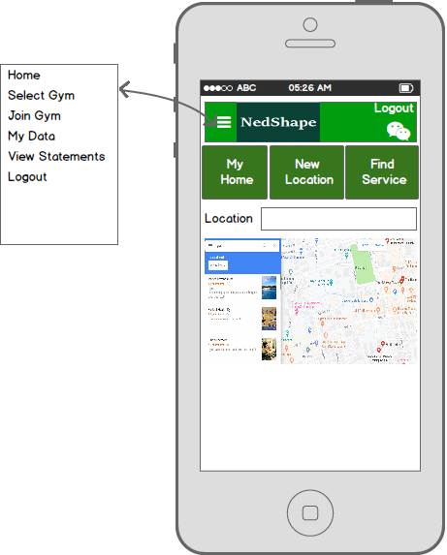

JOIN GYM

Join Gym

Process Characteristics
Process Characteristics Table
Process Name: | Join a selected gym, display all the detail of the gym including time
Process Number: | UC 00006
Process Background: | This process allows member users to select a Gym to join, by using their own address as MY HOME, or a entered location or a specific Gym Type/Service
Process Objectives: | Select a gym using gps coordinates for a selected location or a specific type of gym or gym offering a specific service | Process High Level Key Activities: | - Allow user to search for gyms near their home, a specific location or a type of gym  - Allow the user to click on the gyms for more information  - Allow the user to select a gym to join  - Link the member to the gym
Precondition | User must be a member | Screen Layout | 6.8.1.2
Constraints: |  | Target Clients: | Prospective Member
Trigger From: | Menu Selection – Select a Gym | Trigger To: | Join a Gym
Rules: | - Display the selected gym details and allow the user to click on join or cancel  - Once join is clicked allow the user to access gym specific information and complete required information and pass control to the Iveri API for payment collection  - If the user is not a valid user, i.e the account number does not fall within the Nedbank accounts, Display message, “This is not a valid Nedbank Account, membership on Nedshape is restricted to Nedbank account holders” and request the user to enter a Nedbank account or Cancel  - Once the payment completes successfully store payment information under UserPayments including the date, the amount, a reference to the payment  - Send an email to the member with the policy document pertaining to the rewards system and that the gym will be in contact with them with a Gym Member number within n number of hours (the n number of hours will be stored on the gym Configuration table)  - Link the member to the gym
Actor: | Members and prospective members

Step No: | Step Name | Step Description | Input |  |  | Output | Step Type | Data Elements | Message | Rules
TRIGGER 1
1. | Search for Gym | Allow the user to search for a suitable gym | Gyms  User Address |  | UserGym |  | User/System | UserGym | None | 1-2
2. | Chosen Gym | Once the user has found a gym and clicks on the gym, allow the user to either click on join or cancel. The cancel button should take the user back to the Select Gym page. | User  Gym |  | UserGym |  | User/System | UserGym | None | 1-2
3 | Join a Gym | When the user selects Join, call the Membership payment service provider using an API | User  API |  | UserPayment |  | User and API | UserGym  User Payment | None | 3
4. | Store Payment specific detail once User has paid membership | Iveri Payment will facilitate the Credit Card or debit card. Some of the payment information must be stored on the paper |  |  |  |  |  |  |  | 4-6
5 | Add Membership Payment | Iveri Payment Solutions is the chosen payment service provider – The Iveri API document will be distributed |  | API | Payment |  | System/Users |  | Yes | 4=6

Join Gym

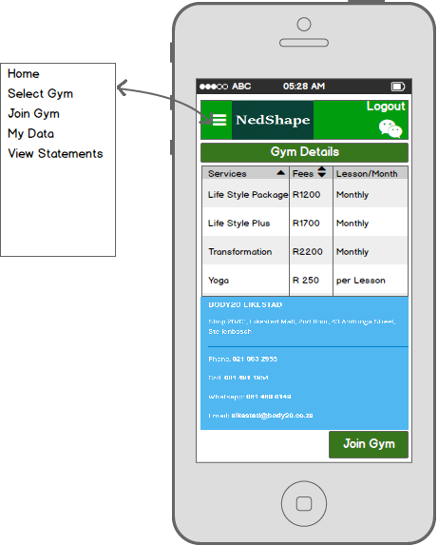

PAYMENT API

PAYMENT API

Process Characteristics
Process Characteristics Table
Process Name: | Payment API
Process Number: | UC 00006- API
Process Background: | This process facilitates the Iveri component.
Process Objectives: | Facilitate payment via credit or debit card | Process High Level Key Activities: | - Facilitate payment  - Pass Nedshape payment date, payment amount and a payment reference allocated by Iveri
Precondition |  | Screen Layout | 6.9.1.3
Constraints: |  | Target Clients: | Prospective Member
Trigger From: | Join Gym | Trigger To: | Iveri API
Rules: | - Pass data required by API and save to Payment record  - Call API  - Receive payment reference and other required information from Iveri  - Store Payment record – token to be supplied by Iveri  - Keep audit trail  - Kick off Welcome letter and Terms and Conditions to the member
Actor: | System

Step No: | Step Name | Step Description | Input | Output |  | Step Type | Data Elements | Message | Rules
TRIGGER 1
1. | Save payment record for user | Add payment record for user with payment date and time, amount, payment reference | Payment data  User |  | UserPayments | User/System | UserPayments | None | 1,4
2. | Pass control to API | Pass all details required for payment to API | API data |  | API Posting | User/System | API | None | 2-4
3 | Update Payment record | Get API reference, Update payment instruction reference | Payment Data |  | UserPayments | User | API
4 | Successful Payment | Upon Successful payment initiate the welcome letter to the client as well contract | User |  | User Documents | User/System |  | None
5 | Keep Audit Log of payment instructions | Update Audit Log | System |  | Audit Log | User

Also see API document

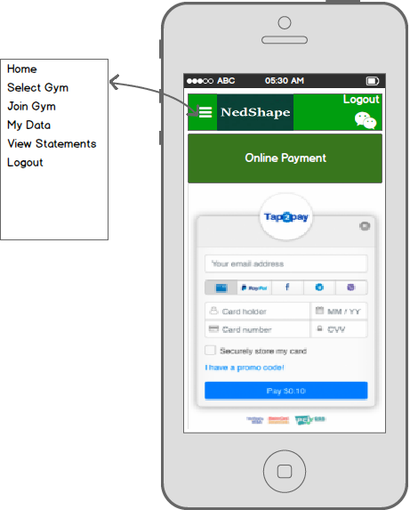

ARRANGE FIRST VISIT

Process Characteristics
Process Characteristics Table
Process Name: | Arrange first visit.
Process Number: | UC 00007
Process Background: | This process allow the member to receive their membership number before making the first visit to the gym. Upon receiving the Gym member number from the gym via email, a link will include the process / link to the system to arrange the first visit to the gym.
Process Objectives: | Update the member with the gym membership number and arrange a first visit | Process High Level Key Activities: | - Update the Gym membership Number  - Arrange fist visit to the gym
Precondition | User must have access to add and update Back Office Users | Screen Layout | 6.10.2
Constraints: |  | Target Clients: | Members
Trigger From: | Menu Selection – | Trigger To: | Email with gym membership number and first visit to the gym
Rules: | - Once a gym has allocated a gym membership number to the member via the system an email must be sent to the member containing  - A gym membership number  - Link to arrange the first visit to the gym  - When the member clicks on the first visit link, the system should allow the user to sign on and select the most convenient time and date for the first visit to the gym (use calendar window)  - Check the time and dates to select from are within the hours of the gym  - The date and time must be in the future  - The time and date must be at least 24 hours before the visit is scheduled  - Record the date and time  - Send an email to the gym informing them of the time and date of the member’s first visit  - Include member number  - Date and time of visit  - This function can only be initiated once for each time that the member joins a gym
Actor: | Members

Step No: | Step Name | Step Description | Input | Output |  | Step Type | Data Elements | Message | Rules
TRIGGER 1
1. | Click on Link | When the user clicks on the link in the membership email, allow the user to sign-on but take the user to the First time visit page. | Users |  | Users | User/System | Users | None | 1,2
2. | Select First Time visit | Allow the member to select the most convenient time to visit the gym they joined for the first time. | User  UserGym  Gym |  | UserGym | User/System | User  UserGym | None | 3-8
3 | Email Gym | Email Gym to notify of the first time visit of the member | UserGym |  | Email | User/System | Gym |  | 7

Book First Visit
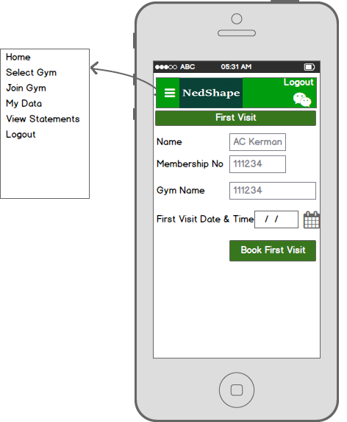

MEMBERSHIP DATA

Process Characteristics
Process Characteristics Table
Process Name: | Membership data
Process Number: | UC 00008
Process Background: | The member has access to their own data to update as necessary.
Process Objectives: | Update member data | Process High Level Key Activities: | - Update member data
Precondition |  | Screen Layout | 6.11.2
Constraints: |  | Target Clients: | Members
Trigger From: | Menu Selection – Member data | Trigger To: | Update member data
Rules: | - Display all member details  - Allow user to update member details  - Keep an audit trail of any changes to member data
Actor: | Members

Step No: | Step Name | Step Description | Input | Output |  | Step Type | Data Elements | Message | Rules
TRIGGER 1
1. | Display Member data | Display member data | User |  | Users | User/System | Users | None | 1
2. | Update member data | Allow user to update member data | User  UserGym  Gym |  | UserGym | User/System | User  UserGym | None | 2-3

MEMBER DETAILS
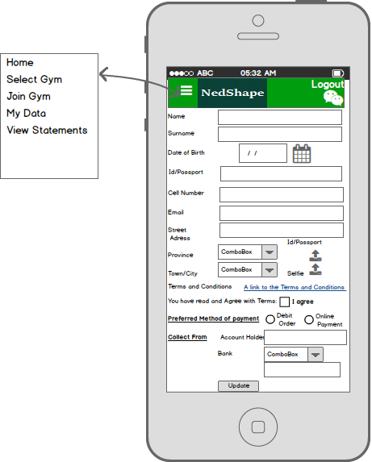

Member : Statements

Process Characteristics
Process Characteristics Table
Process Name: | Member Statement Page
Process Number: | UC 000009
Process Background: | The statement page will list all statements for the last year for the member to view.
Process Objectives: | Ability for agent to member view statements | Process High Level Key Activities: | - List a year’s worth of statements  - Allow the user to select the statement they want to view by double clicking on the statement  - Display the statement in PDF format
Precondition |  | Screen Layout | 6.12.2
Constraints: | Only 24 statements will be available | Target Clients: | Members app
Trigger From: | Menu | Trigger To: | Statements
Rules: | - List statements for last 12 months for the member in date descending order as default  - Allow user to double click on a statement to open a PDF view of the statement  - Allow user to export list of statements  - Allow user to select statements to view by entering a start and end date for selection
Actor: | Members

Members Statement Page

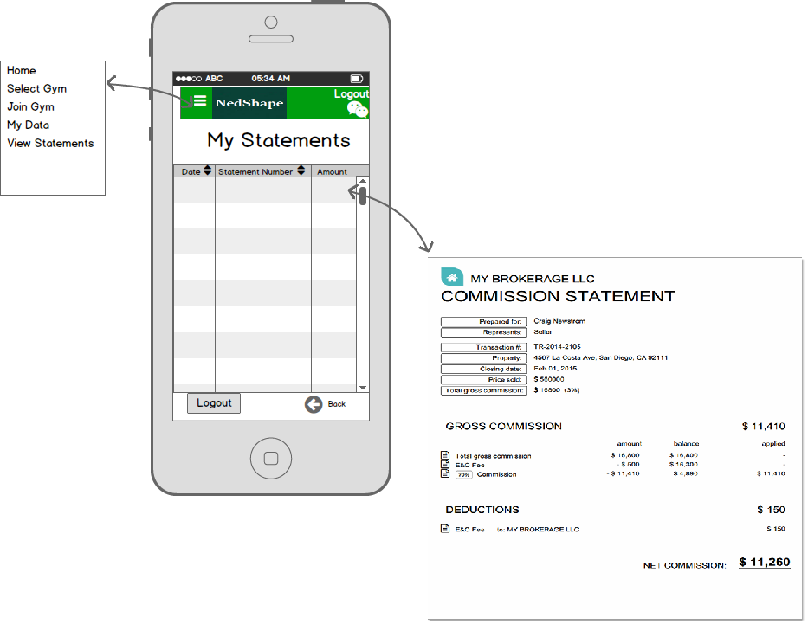

Gym System Config

Process Characteristics
Process Characteristics Table
Process Name: | System Configs for Gyms
Process Number: | UC 0010
Process Background: | All variables for gyms in the system will be kept in the System Config table for management by the Gym System Administrator
Process Objectives: | Keep Configs maintained | Process High Level Key Activities: | - Allow Gym admin user to update config table and variables as required
Precondition | Only Gym System Admin has access to this function | Screen Layout | 6.13.2
Constraints: | This record must exist and may NEVER be deleted | Target Clients: | Gym System Administrator
Trigger From: | Menu Selection – Gym System Administration, System Configuration | Trigger To: | System Configuration
Rules: | - List all Config variables  - Allow user to change the values of the variables  - Keep an audit of all changes made to the Config table  - Fields updated by the system like last run dates may not be edited.  - Write an import to import the initial Gyms and the config tables for each gym, write out exception report for those gyms that could not be imported and give reason
Actor: | Gym System Admin

Step No: | Step Name | Step Description | Input | Output |  | Step Type | Data Elements | Message | Rules
TRIGGER 1
1. | List Variables | List gym variables and allow user to change | GymConfig |  | GymConfig | User/System | GymConfig | None | 1,2,3,4
2 | Write initial import of Gyms and associated config tables | Initial take on of gyms and associated Config Tables and generate exception report | GymConfig |  | GymConfig | Systme | GymConfig |  | 5

Gym Config Page
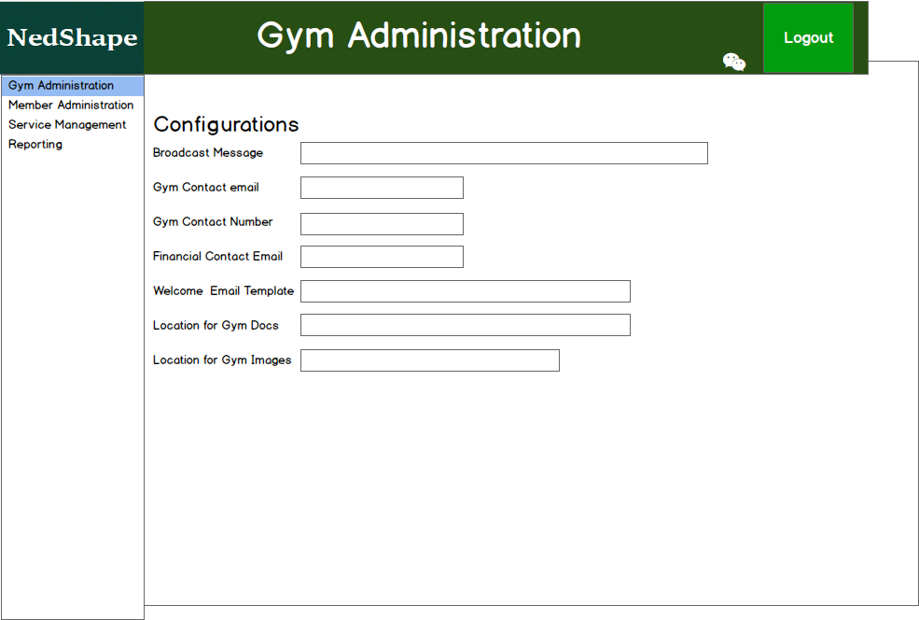

Audit Log

Process Characteristics
Process Characteristics Table
Process Name: | Audit Log Report
Process Number: | UC 0010
Process Background: | All changes to the database will be recorded, together with the date and time of change, the person making the change, the action taken, the before and after images of the change
Process Objectives: | Keep Track of all changes on the system | Process High Level Key Activities: | - Keep track of all actions on the system
Precondition |  | Screen Layout | 614.2
Constraints: |  | Target Clients: | System Administrator
Trigger From: | Menu Selection – System Administration, Audit Log | Trigger To: | Audit Log
Rules: | - List all Audit Log Records  - Allow search on all fields or specific fields  - Allow report export to CSV
Actor: | System Admin

Step No: | Step Name | Step Description | Input | Output |  | Step Type | Data Elements | Message | Rules
TRIGGER 1
1. | List Audit Log Records | Allow the user to filter the audit log list by using the search function and allow the user to export the report to a csv file | AuditLog |  | Page | User/System | AuditLog | None | 1,2,3

AuditLog Page

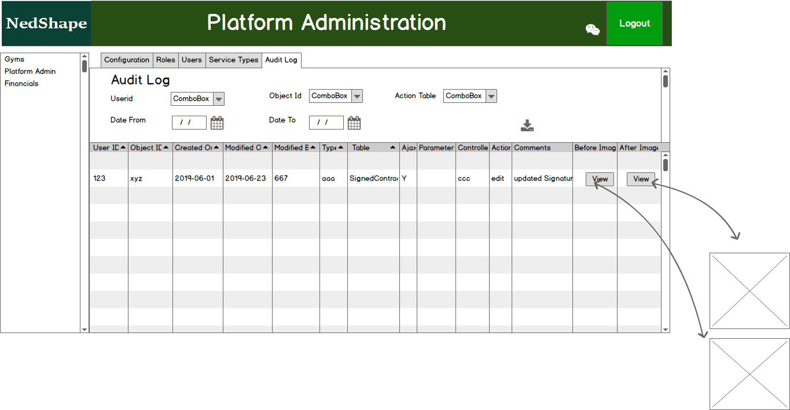

Collections

Process Characteristics
Process Characteristics Table
Process Name: | All funds collected or paid by the member
Process Number: | UC 0011
Process Background: | All payments made by the member for membership fees
Process Objectives: | Allow the Financial manager to view all payments made by members | Process High Level Key Activities: | - List all payments made by members
Precondition |  | Screen Layout | 6.15.2
Constraints: |  | Target Clients: | System Administrator
Trigger From: | Menu Selection – Finance | Trigger To: | Collections
Rules: | - List all Collections/payments made by members Records (default to last month)  - Allow user to select from and to date range to list payments for  - Also allow user to select a specific gym  - Allow report export to CSV
Actor: | System Admin

Step No: | Step Name | Step Description | Input | Output |  | Step Type | Data Elements | Message | Rules
TRIGGER 1
1. | List Payments made by members | List all payment made by members based on the selection criteria | Memberfees |  | Page | User/System | Memberfees | None | 1,2,3
2 | Export data | Allow user to export data to a csv file | Memberfees |  | Page | User/System | Csv File |  | 4

Collections

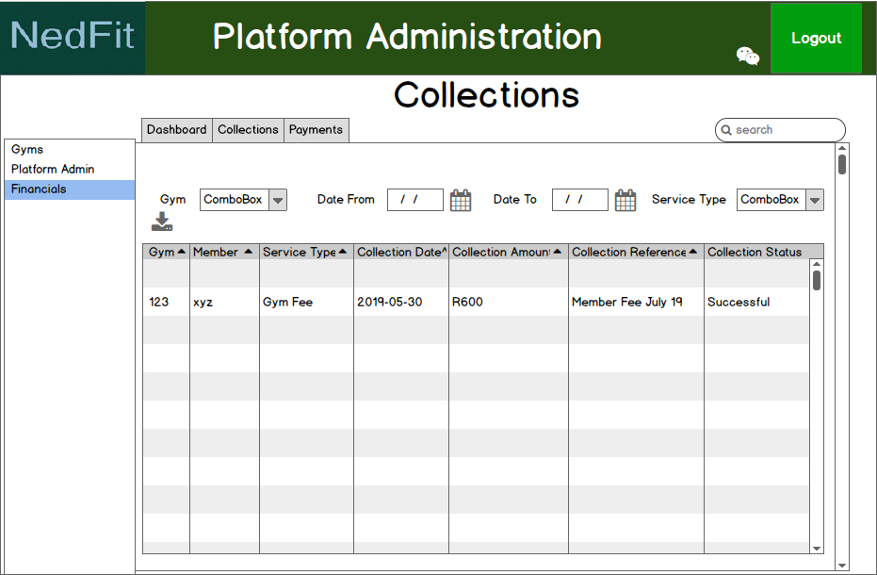

SPRINT 2 (functions marked in blue)

The second sprint concentrates on the platform functions that are marked in blue and includes some batch processes. Sprint 2 establishes back office functionality. This allows the Platform administrator and back office users to manage the system.

Gym and service Management

List of Gyms

Process Characteristics
Process Characteristics Table
Process Name: | List all active Gyms
Process Number: | UC 0012
Process Background: | List of Gyms active on the system.
Process Objectives: | Allow back office users to view the active gyms stored on the system | Process High Level Key Activities: | - List all active gyms
Precondition |  | Screen Layout | 7.1.1.2
Constraints: |  | Target Clients: | System Administrator
Trigger From: | Menu Selection – Manage Gyms and Services | Trigger To: | List of gyms
Rules: | - List all active gyms and their services  - Allow the user to select a specific gym by entering a name or part of a name  - Also allow user to select a service and show all the gyms that offer the service  - Allow user to input an address and show all users within 100 km of the address  - Allow user to easily terminate a gym by marking it inactive.  - Allow report export to CSV
Actor: | System Admin, back office users

Step No: | Step Name | Step Description | Input | Output |  | Step Type | Data Elements | Message | Rules
TRIGGER 1
1. | List of active Gyms | List all gyms that are not waiting for activation | Gyms |  | Page | System | Gyms | None | 1
2 | Searching Gyms | Allow the user to filter the list of gyms by using the search criterial | Gyms |  | Page | User/System | Gyms | None | 2.3.4
3 | Activate/Deactivate Gym | Allow a user to activate or deactivate a gym by clicking on an activate/Deactivate Icon | Gyms |  | Page | User/System | Gyms | None | 5
4 | Export CSV File | Allow the user to export selected data to a CSV file and save to downloads folder | Gyms |  | Page | User/System | Gyms | Non | 6

Activated Gyms List
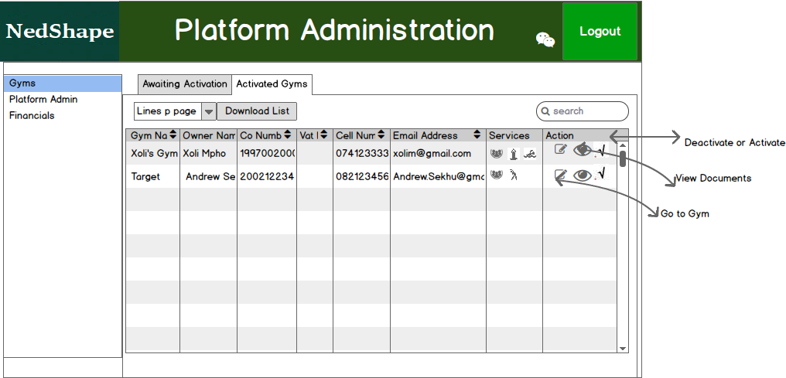

Platform Administration

Platform Configs

Process Characteristics
Process Characteristics Table
Process Name: | View and edit the Platform Configs
Process Number: | UC 0013
Process Background: | Display Platform Configs and allow user to Edit. There will always only be one record with all the variables. No need to write an add function because this table will be populated by an initial script.
Process Objectives: | Allow Platform Admin users to view and edit the Config fields | Process High Level Key Activities: | - Show all fields in the PlatformConfig table
Precondition |  | Screen Layout | 7.2.1.2
Constraints: |  | Target Clients: | Platform System Administrator
Trigger From: | Platform Administration Selection – Configuration | Trigger To: | Configuration
Rules: | - Display System Configuration  - Check that folders captured exist  - Payment Day can only be 1 to 31  - Allow user to change the config fields but some are protected like the last run dates, these may not be changed  - Allow the user to add a broadcast that should be saved to the broadcast table
Actor: | System Admin, back office users

Step No: | Step Name | Step Description | Input | Output |  | Step Type | Data Elements | Message | Rules
TRIGGER 1
1. | Display | List all gyms that are not waiting for activation | Gyms |  | Page | System | Gyms | None | 1-4
2 | Capture Broadcast Message | Allow user to capture a broadcast message | Gyms |  | Page | User/System | Gyms | None | 4

Display System Config fields and Add Broadcast message

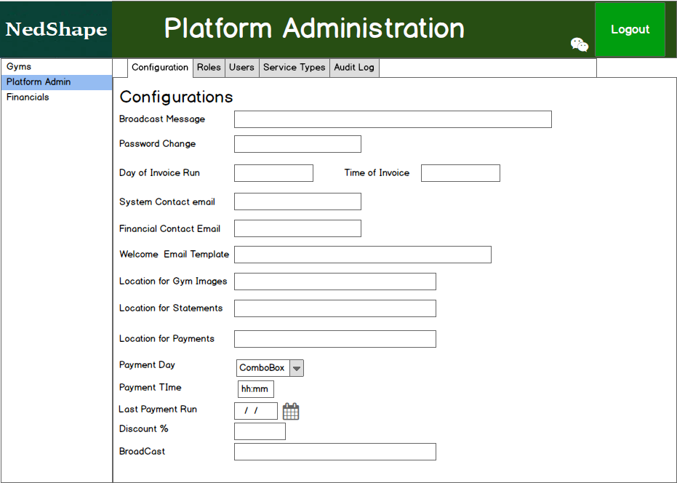

List of Platform Users

Process Characteristics
Process Characteristics Table
Process Name: | List of Platform Users and allow user to add and edit users
Process Number: | UC 0014
Process Background: | List of Platform users. Allow platform administrator to select a user to edit or to add a user.
Process Objectives: | Only allow Platform admin to view and edit the platform users or BO users | Process High Level Key Activities: | - List all active gyms
Precondition |  | Screen Layout | 7.2.2.2
Constraints: |  | Target Clients: | System Administrator, back office users
Trigger From: | Platform Administration Selection – Platform Users | Trigger To: | Platform Users
Rules: | - List all platform users (see UserType)  - Allow the admin user to add a platform user, and send an email to the user with login details and temporary password and mark the user as activated  - When adding or editing an user, the following applies  - the UserType must be set to Platform User  - A role must be allocated to the user  - Date of birth must be completed and must match ID (first 6 characters) if SA Citizen is YES  - There must be a contact number  - There must be an email address – the email address is the user name  - There must be a name and a surname  - Allow the user to select a platform user from the list to edit  - Allow user to easily terminate a user by marking it inactive from the list  - Allow the user to search the list by name, email address, Role or any part of anything displayed on the page  - Allow report export to CSV
Actor: | System Admin

Step No: | Step Name | Step Description | Input | Output |  | Step Type | Data Elements | Message | Rules
TRIGGER 1
1. | List of Platform Users | List of all platform users | Users |  | Page | System | Users | None | 1
2 | Add User | Allow admin to add a platform user | Display |  | Users | User/System | Users | None | 2.3
3 | Edit User | Allow admin to edit an existing user | Users |  | Users | User/System | Users | None | 3,4
4 | Terminate/Activate User | There are two ways to terminate/Activate a user either by editing the user or by clicking on the terminate/activate user on the list | Users |  | Users | User/System | User | None | 5
5 | Search by Filtering data | Allow admin to filter the data by using the search function | Users |  | Users | Users/System | Users | None | 6
7 | Export CSV File | Allow the user to export selected data to a CSV file and save to downloads folder | Usres |  | File | User/System | Users | Non | 7

List of Users

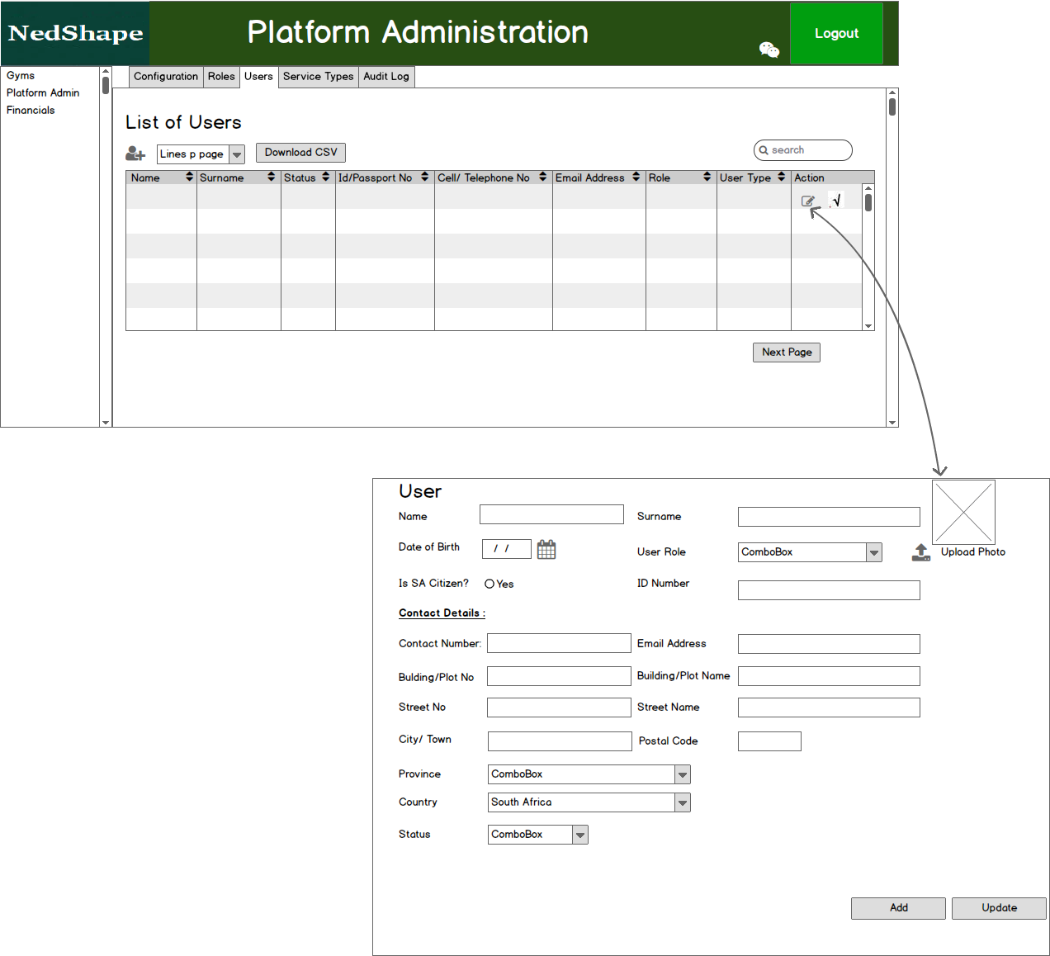

List of Services/Products Types

Process Characteristics
Process Characteristics Table
Process Name: | List of Services and Products Types captured on the Platform
Process Number: | UC 0016
Process Background: | List all product/service types on the platform and allow the user to edit, terminate or add new types
Process Objectives: | List all products and services offered on the platform and that Gyms can link to. This will indicate to members which services/products are offered by the gym | Process High Level Key Activities: | - List all active gyms
Precondition |  | Screen Layout | 7.2.3.2
Constraints: |  | Target Clients: | System Administrator
Trigger From: | Menu Selection – Platform Admin | Trigger To: | List of gyms
Rules: | - List all Product and Service type on the platform  - Allow the user to Add a service/product  - Allow the user to select a service type record to edit  - Allow user to easily terminate a service by marking it inactive.  - Allow report export to CSV
Actor: | System Admin

Step No: | Step Name | Step Description | Input | Output |  | Step Type | Data Elements | Message | Rules
TRIGGER 1
1. | List of Services/Products on the platform | List all services and products on the platform | Services |  | Page | System | Services | None | 1
2 | Add Service/Product Type | Allow user to add service or product to the platform | Page |  | Services | User/System | Services | None | 2
3 | Edit Service/Product Type | Allow user to edit a service/Product type | Services |  | Services | User/System | Services | None | 3
4 | Activate/Deactivate Service | Allow a user to activate or deactivate a Services/Product by clicking on an activate/Deactivate Icon | Services |  | Services | User/System | Services | None | 4
5 | Export CSV File | Allow the user to export selected data to a CSV file and save to downloads folder | Services |  | File | User/System | Services | None | 5

Products/Services Page

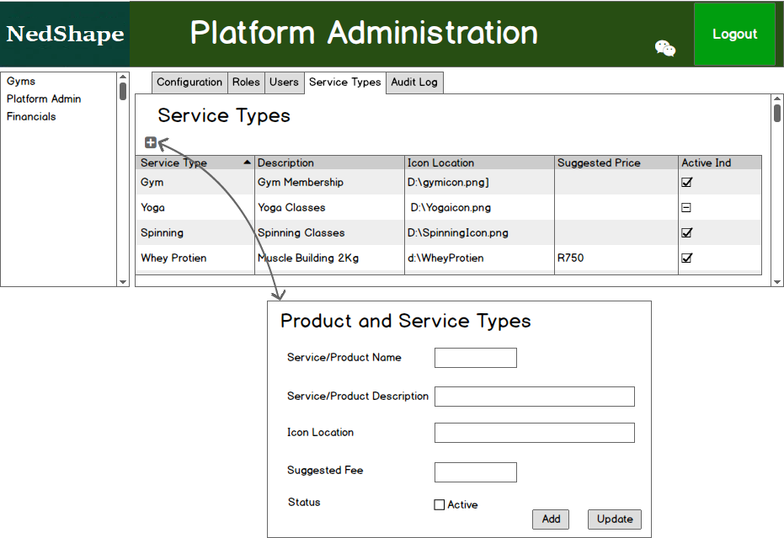

Platform Finance

List of Membership Statements

Process Characteristics
Process Characteristics Table
Process Name: | List of membership statements sorted in date and member name and surname sequence
Process Number: | UC 0017
Process Background: | List all member statements
Process Objectives: | List all Statements for the last month but allow the user to select a specific period (date range) and other filters such as MembershipNo, Email Address, ect. | Process High Level Key Activities: | - List all member statements for the last month  - Allow user to select which statements to view by using the search function
Precondition |  | Screen Layout | 7.2.3.2
Constraints: |  | Target Clients: | System Administrator, Back Office Finance User
Trigger From: | Menu Selection – Platform Finance | Trigger To: | List member Statements
Rules: | - List all member statements for the last month (see the user type)  - Allow the user to select specific information or extend the date range of data to view by using the search Function  - Allow the user to select a specific statement to resend to member or download to their download folder  - Allow list export to CSV
Actor: | System Admin

Step No: | Step Name | Step Description | Input | Output |  | Step Type | Data Elements | Message | Rules
TRIGGER 1
1. | List member Statements | List all member statements the last month | UserStatemetns |  | Page | System | UserStatements | None | 1
2 | Allow user to search data | Allow user to change selection of data by either changing the date range, membershipno, Gym, reference number | UserStatements |  | UserStatements | User/System | UserStatements | None | 2
3 | Email/Download Statement | Allow the user to (re)email the statement to the member or to download the statement | UserStatements |  | UserStatements | User/System | UserStatements | None | 3
4 | Export CSV File | Allow the user to export selected data to a CSV file and save to downloads folder | UserStatements |  | File | User/System | UserStatements | None | 4

Member Statements Page
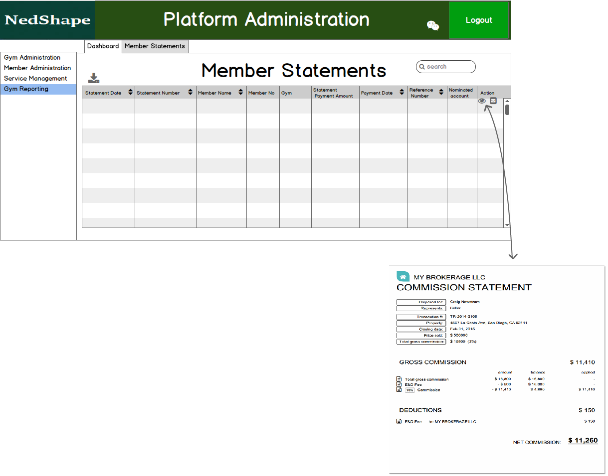

List of Gym Payments

Process Characteristics
Process Characteristics Table
Process Name: | List of Gym payments sorted in date and Gym name
Process Number: | UC 0018
Process Background: | List all member statements
Process Objectives: | List all Payments for the last month but allow the user to select a specific period (date range) and other filters such as Gym Name, Email Address, ect. | Process High Level Key Activities: | - List all Gym Payments for the last month  - Allow user to select which payments to view by using the search function
Precondition |  | Screen Layout | 7.2.3.2
Constraints: |  | Target Clients: | System Administrator, Back Office Finance User
Trigger From: | Menu Selection – Platform Finance | Trigger To: | List Payments
Rules: | - List all Gym Payments for the last month (see the user type)  - Only display the last 4 characters of the account number preceded by ****  - Allow the user to select specific information or extend the date range of data to view by using the search Function  - Allow list export to CSV
Actor: | System Admin

Step No: | Step Name | Step Description | Input | Output |  | Step Type | Data Elements | Message | Rules
TRIGGER 1
1. | List Gym Payments | List all Gym Payments the last month | UserPayments |  | Page | System | UserPayments | None | 1,2
2 | Allow user to search data | Allow user to change selection of data by either changing the date range, membershipno, Gym, reference number | UserPayments |  | UserPayments | User/System | UserPayments | None | 3
3 | Export CSV File | Allow the user to export selected data to a CSV file and save to downloads folder | UserPayments |  | File | User/System | UserPayments | None | 4

Gym Payments Page
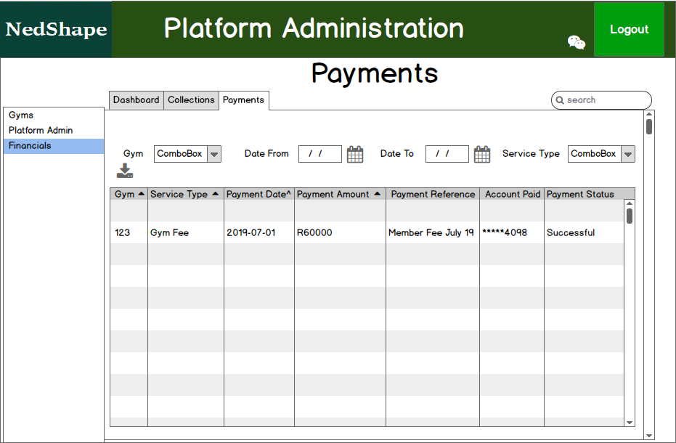

Batch Monitor Programs

Generate Member Statements

Process Characteristics
Process Characteristics Table
Process Name: | Monthly the Statements for the members should be generated and stored as PDF, at the same time the UserStatements table must be updated for each user with user type = member
Process Number: | UC 0019
Process Background: | Generate member statements and update UserStatements table with new statement information that was generated.
Process Objectives: | Generate the membership statements per Member and store a summary link on the UserStatements table | Process High Level Key Activities: | - Generate statements and store in specific location  - Update the UserStatements Table with a summary of the statement for quick reference purposes
Precondition |  | Screen Layout | 7.4.1.2
Constraints: |  | Target Clients: | Batch Monitor
Trigger From: | Batch Monitor | Trigger To: | Generate Member Statements
Rules: | - On the same day that the gym payments run and proceeding the Payments batch program, the member statements must be generated. See the config file for the day of the payment run.  - If the day falls on a Saturday, Sunday or public holiday, then run the statements on the next working day.  - Generate the statement in PDF format and save to specified location that will be referenced by the UserStatement record that is stored at the same time  - Include all payment made by the member since the lastpaymentrun date  - The Userstatement record must be a summary of all payments made by a member user on the UserPayments table  - Each statement should be sent to the Member user’s email address.  - Create a log file as processing is initiated for diagnostic and management purposes
Actor: | Batch

Step No: | Step Name | Step Description | Input | Output |  | Step Type | Data Elements | Message | Rules
TRIGGER 1
1. | Check If Statements must run | Check if the Paydate and Paytime has been reached, if not terminate run | SystemConfig |  |  | System |  | None | 1,2
2 | Generate the PDF statement | Generate the PDF statement from | UserPayments  SystemConfig |  | UserStatements | System | UserStatement | None | 3,4,5
3 | Email statement to member user | Email the generated statement to the member | PDF  Users |  | Email | System | UserStatement | None | 6
4 | Generate Log file | The batch program should generate a logfile to make diagnostics and monitoring easier |  |  | LogFile | System |  | None | 7

Statement Layout
tba

Generate Gym Payments

Process Characteristics
Process Characteristics Table
Process Name: | Monthly payments to gyms
Process Number: | UC 0020
Process Background: | On a monthly basis the fees collected for gyms must be paid over to the gyms
Process Objectives: | Generate a payment file that will be sent to the bank for payment | Process High Level Key Activities: | - Generate the Gym Payment File
Precondition |  | Screen Layout | 7.4.2.2
Constraints: |  | Target Clients: | Batch Monitor
Trigger From: | Batch Monitor | Trigger To: | Generate Gym Payments
Rules: | - See the config file for the day and time that the payment run must run.  - If the day falls on a Saturday, Sunday or public holiday, then run the statements on the next working day.  - Generate the header record as specified in the format below using the account details and user code on the SystemConfig table  - Generate the statement in PDF format and save to specified location that will be referenced by the UserStatement record that is stored at the same time  - Include all collections received from all member of a specific gym since the lastpaymentrun date on the SystemConfig table and calculate a % of all collection amount, this % can be found on the system Config table  - The calculated amount must be subtracted from the total of all a members collections since lastpaymentrun and the remaining amount must be used when generating the payment record  - The gym account number, branch and name must be used in each detail record, the payment date or action date will be today’s date  - Reference should be Year and Month followed by MEMBER FEE  - Also store the information on the GymPayments Table  - Once all member payment records are processed a trailer record must be generated according to the file layout below. This record should include the number of payment records generated as well as the total amount of all payments generated.  - Generate a list of member payments less % (as on system config) that were included in the payment calculation per gym in csv format and email to the gym email address with subject MEMERS PAID AS ON <DATE>  - The amount paid to the gym should be the same as the total amount on the latter list.  - Create a log file as processing is initiated for diagnostic and management purposes
Actor: | Batch

Step No: | Step Name | Step Description | Input | Output |  | Step Type | Data Elements | Message | Rules
TRIGGER 1
1. | Check If Payments must run | Check if the Paydate and Paytime has been reached, if not terminate run | SystemConfig |  |  | System |  | None | 1,2
2 | Generate the Payment File | Generate payment file | UserPayments  SystemConfig |  | UserStatements | System | UserStatement | None | 3 - 10
3 | Email gym list of members that paid | Email the generated statement to the member | PDF  Users |  | Email | System | UserStatement | None | 11-12
4 | Generate Log file | The batch program should generate a logfile to make diagnotics and monitoring easier |  |  | Logfile | System | Logfile | None | 13

Payment Layout
File Format is Comma Delimited
1. Header Record Layout
Field Name | Max Length | Type | Value | Format | Comment
Record Type | 2 | Numeric | 00 - Credit and Debit iIdentifier
Creation Date | 8 | Numeric | Date | CCYYMMDD | The date the file has been created
UserCode | 4 | Alpha Numeric |  |  | As provided by SureTrasact
User Nominated Account | 11 | Numeric |  |  | As provided by SureTrasact
Service | 10 | Alpha Numeric | SAMEDAY ONEDAY TWODAY CREDIT  RTC |  | Payments, Collections  Salaries  Collections  Payments to credit cards  Real-time (immediate) payments
2. Transaction Record Layout
Field Name | Max Length | Type | Value | Format | Comment
Record Type | 2 | Numeric | 10 - Credit Transaction ID  50 - Debit Transaction ID
Beneficiary Bank Branch Code | 6 | Numeric |  |  | For Credit card payments this field must be left empty.
Beneficiary Account Number | 13 | Numeric |  |  | For Credit card payments this field must be left empty.
Beneficiary Account Name | 30 | Alpha Numeric | A - Z ALPHABETIC (Upper case only)  0 - 9 NUMERIC  < LESS THAN  . PERIOD  + PLUS  / OBLIQUE SLASH  $ DOLLAR  - HYPHEN  ; SEMI-COLON  & AMPERSAND  > GREATER THAN  * ASTERISK  = EQUAL  , COMMA  ‘ QUOTE  ( LEFT PARENTHESIS  ) RIGHT PARENTHESIS  SPACE
Reference Number | 20 | Alpha Numeric | A - Z ALPHABETIC (Upper case only)  0 - 9 NUMERIC  < LESS THAN  . PERIOD  + PLUS  / OBLIQUE SLASH  $ DOLLAR  - HYPHEN  ; SEMI-COLON  & AMPERSAND  > GREATER THAN  * ASTERISK  = EQUAL  , COMMA  ‘ QUOTE  ( LEFT PARENTHESIS  ) RIGHT PARENTHESIS  SPACE |  | For collections the reference field must contain the contract number in the first 14 bytes and the cycle/action date in the last 6 bytes in YYMMDD format.  For Credit Card Payments this field must contain the credit card number, no spaces in between and left justified.
Action Date | 6 | Numeric |  | YYMMDD | The date on which a debit or credit must be effected on the homing account
Amount | 12 | Numeric |  | Decimal point not assumed | The decimal point must be indicated e.g. R100 must be entered as 100.00 or R20.67 must be entered as 20.67
3. Trailer Record
Field Name | Max Length | Type | Value | Format | Comment
Record Type | 2 | Numeric | 99 |  | Indicated end of file
Total Amount | 20 | Numeric |  | Decimal point not assumed | The decimal point must be indicated e.g. R100 must be entered as 100.00 or R20.67 must be entered as 20.67
Total Quantity | 6 | Numeric |  |  | Total number of transactions excluding header and trailer
Message Digest | 20 | AN | Optional | HEX | Use SHA 1. exclude trailer record when passing data to the algorithm

